**LAB 3**

**Step 1 and 2: Create a MySQL type DB instance in AWS RDS**

1. In Amazon RDS dashboard click on the Launch DB instance link

2. Choose MySQL engine and click next

3. Choose Use case Dev/Test – MySQL

4. Specify DB details

* DB instance class- db.t2.micro ( low space )
* C reate replica in Different Zone
* Storage type – general perpose
* Storage – 20 gb

1. Settings

* DB instance Identifier - **User27MYSQLDB**
* User name - **User27**
* Password - **user27capgemini**

6. Network and security –

* Let it be default , don’t change anything

1. Database Options

* DB name - **User27MYSQLDB**
* Port – **3306**

8. Click on DB launch instance

* Once the instance is available , copy few things
* Endpoint :- **user27mysqlrdsserver.cxbxe7ypeoyt.us-east-1.rds.amazonaws.com**
* Db name :--  **User27MYSQLDB**
* Userid :-- **user27**
* Password:- **user27capgemini**

check the security group -- Type (Any traffic ) and source – (Anywhere)

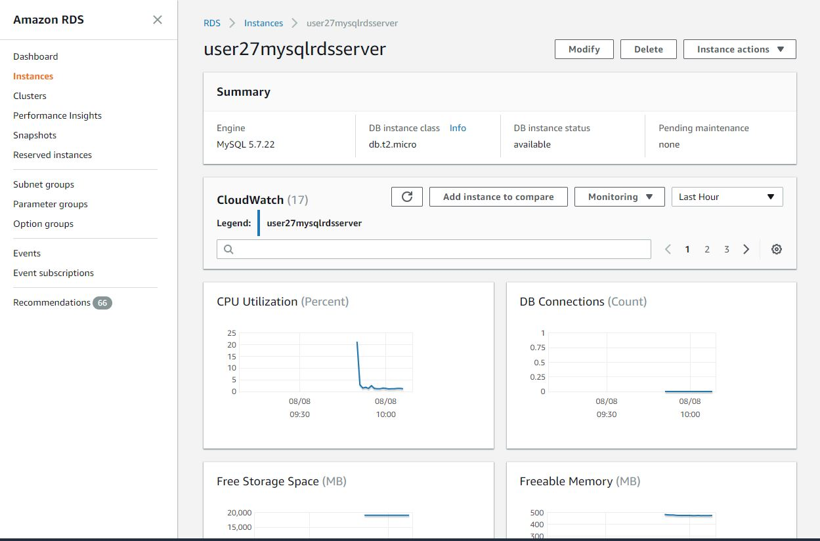

**Step 2: Login to Jack DB**

1. Type [www.jackDb.com](http://www.jackDb.com) Login to

2. Create a account and signI n

3. Add a DataSource of MySQL type

4. Enter DB credentials

* Name - User27MySQLRDSCon
* Host :- Endpoint name of RDS Db instance
* Port :- 3306
* User – User27RDS
* Password – DB password from AWS RDS
* Once Datasource created , connect it.

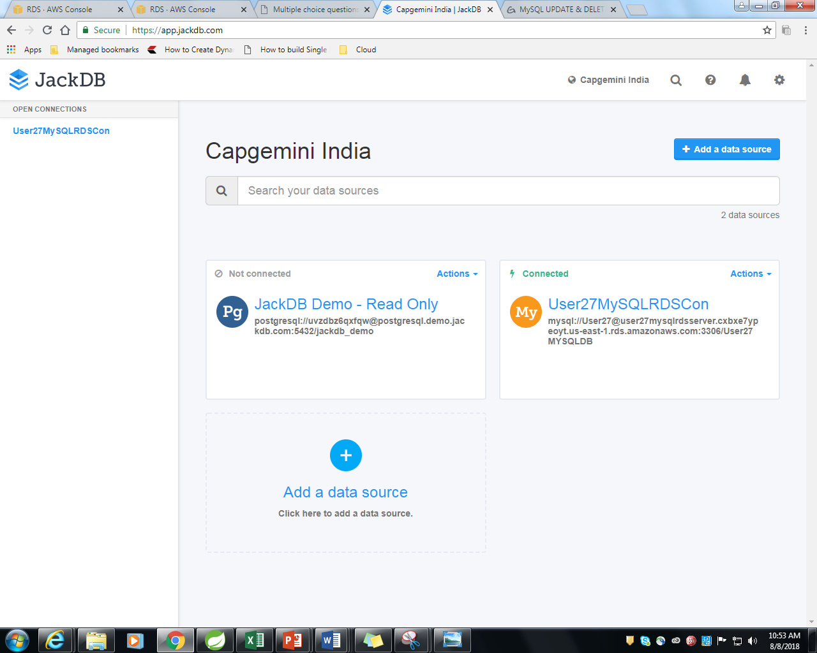

**Step3: Use jackDB MySQL type and configure as per AWS RDS DB type**

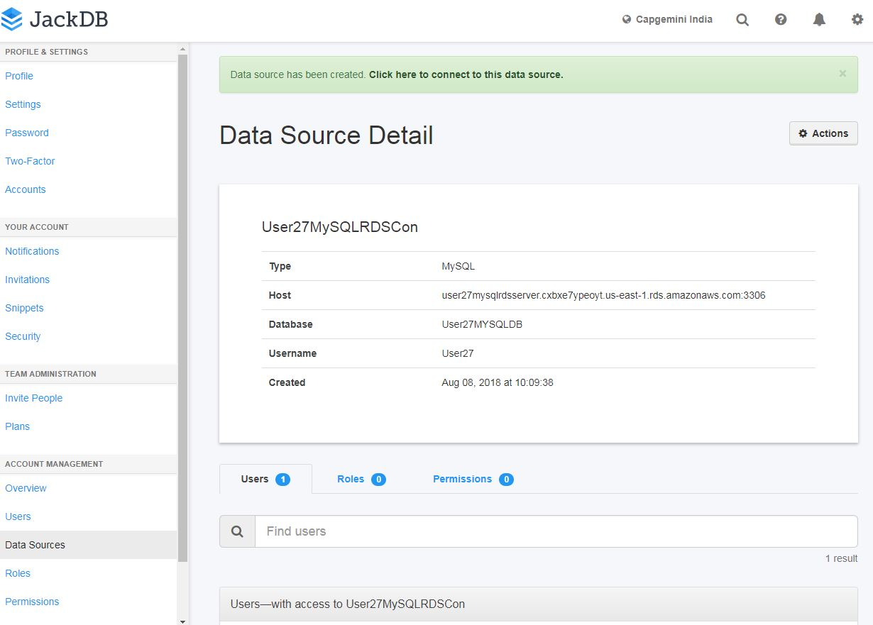

**Step 4: Using The JackDB interface to Create a table Employee with columns (empId , name , salary)**

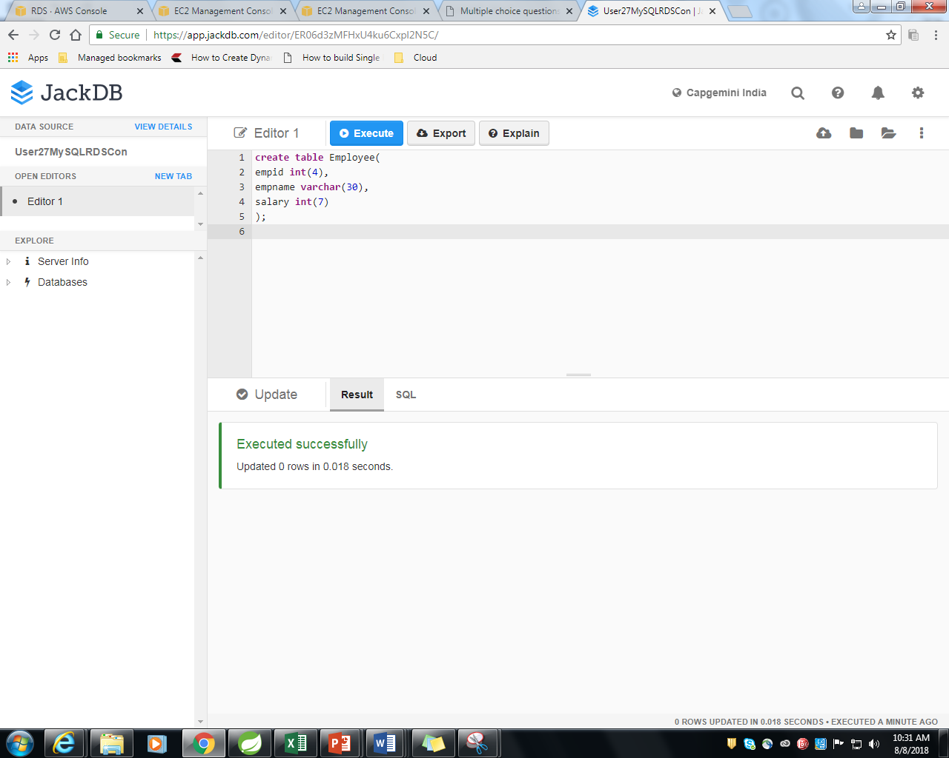

**Step 5: Using DML operation (insert ,update, delete query ) to your table**

1. **Inserting data into table**

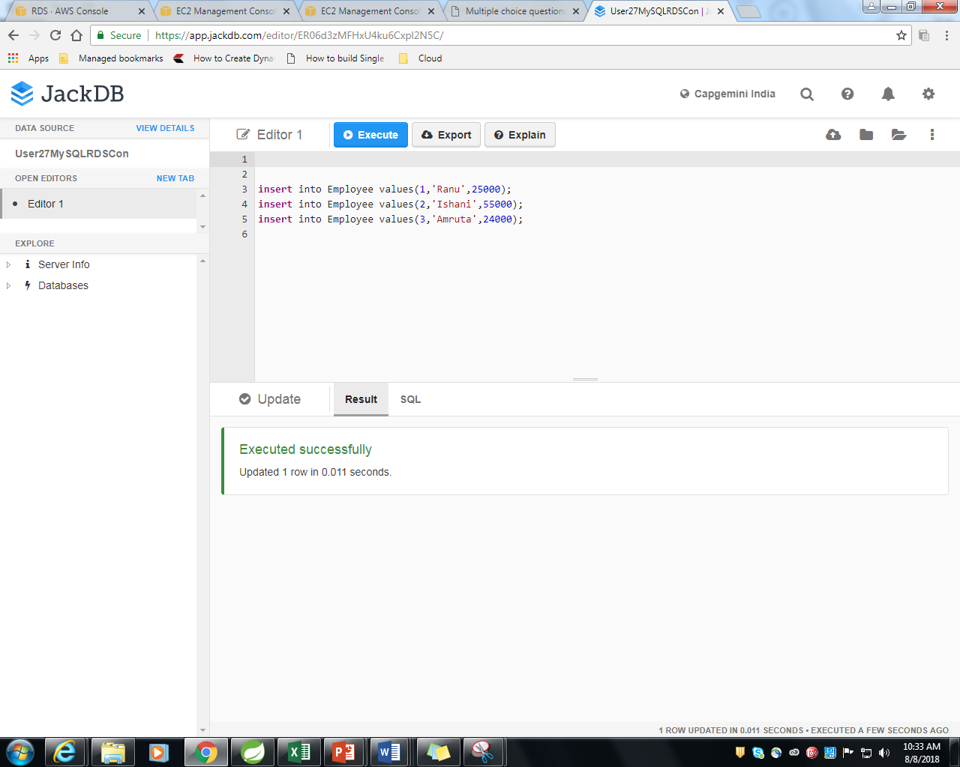

1. **Updating data into table**

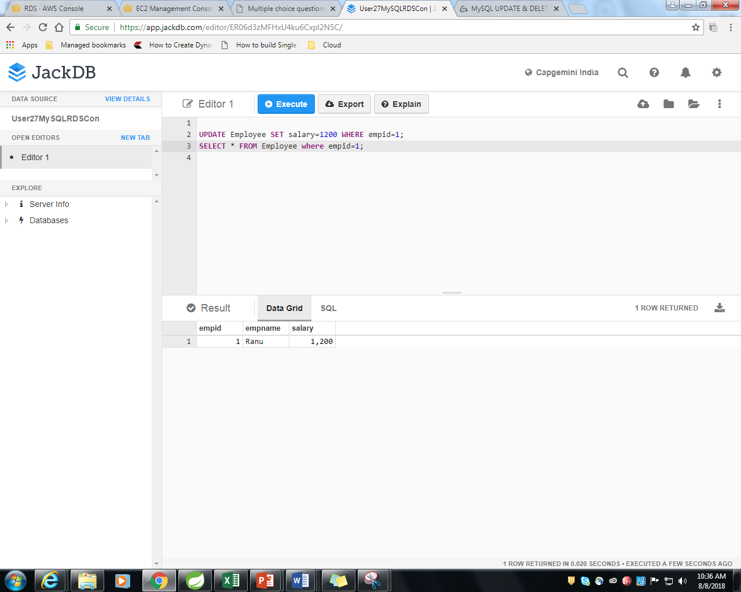

1. **Delete Query**

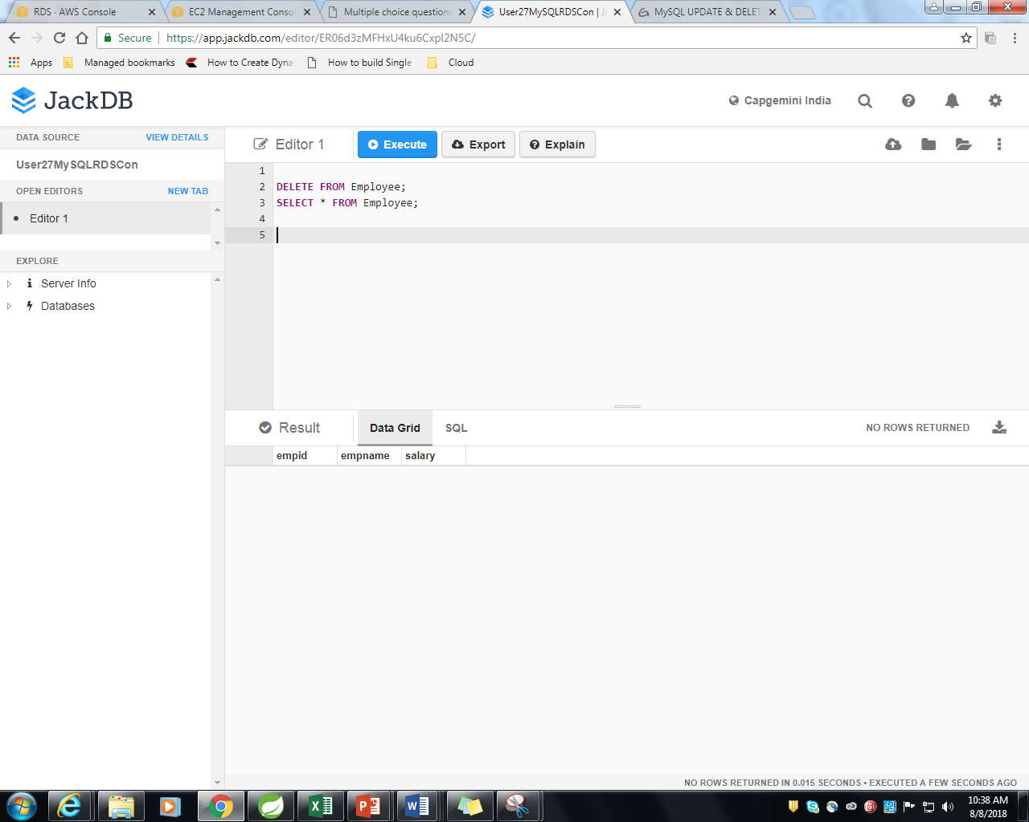

Step 6: **Drop the Table**

